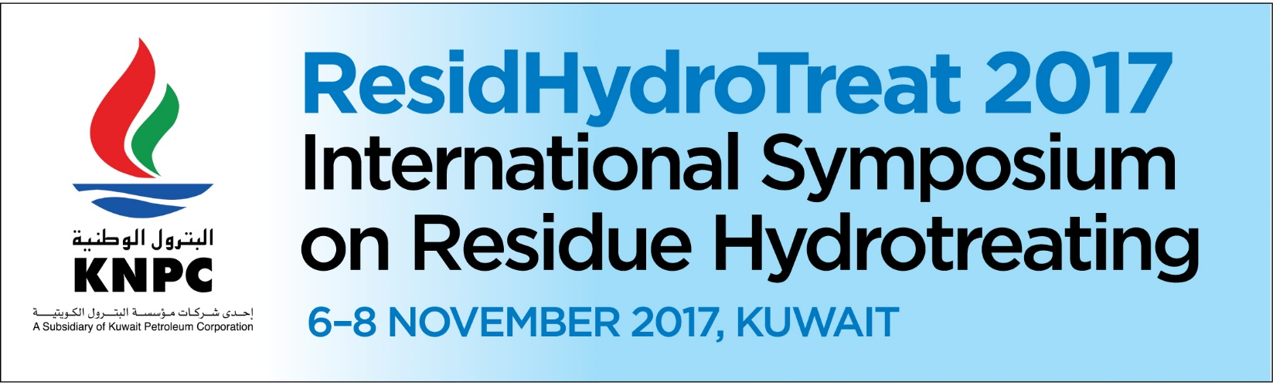

ResidHydroTreat 2017 Submission Form
Kindly provide your contact details as per below:
Speaker’s name: |  |  | Job Title:
Company name: |  |  | Department:
Telephone: |  |  | Fax:
Mobile: |  |  | Email Address:
Postal Address:
Assistant/Coordinator's Details:
Kindly provide a Title :

Kindly provide an Abstract (up to 200 words):

Kindly provide three key bullet points which can be reflected on the Conference Programme.

*We encourage our speakers to provide Written Papers in addition to the PowerPoint Presentations and include videos in their presentations. Average duration of the speaking slot is 30 min (to be confirmed closer to the event).
Is your company interested in Sponsoring the Symposium: |  |  |  |  |  | ◻  Yes |  | ◻ No
Is your company interested in Exhibiting at the Symposium: |  |  |  |  |  | ◻  Yes |  | ◻ No
Please note that we will require the following for the Speakers:
- Photo (high resolution, JPEG)
- Short Bio ( 150-200 words)
- Company's logo (high resolution, JPEG format)

